# Web 3 Assignment 1

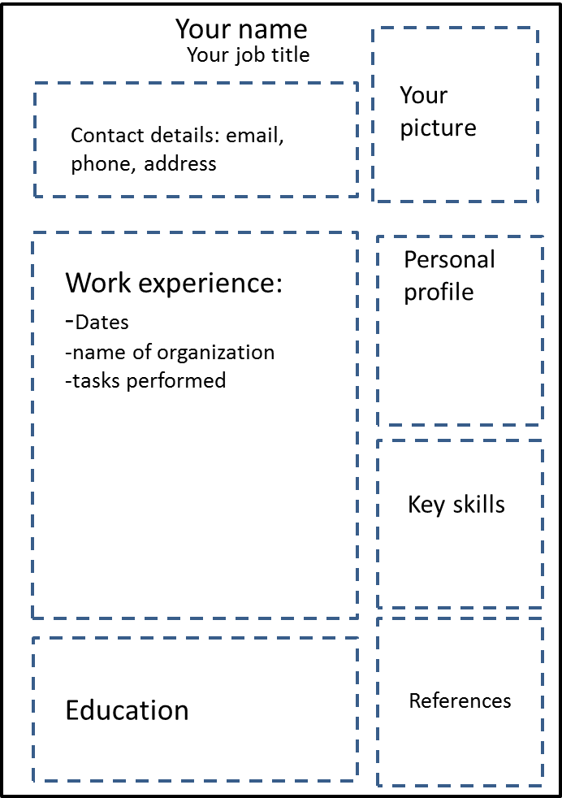

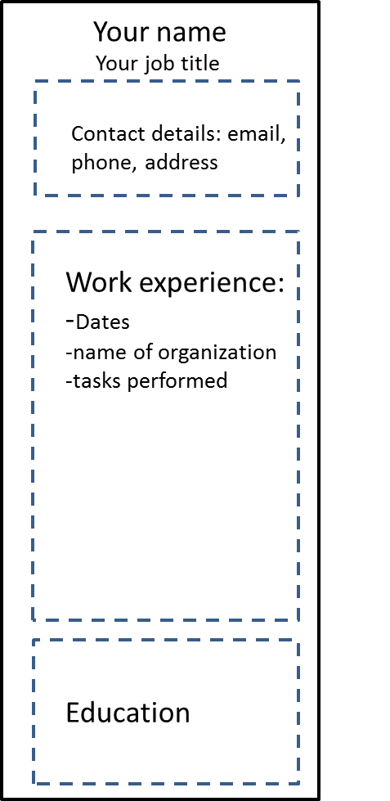

# Group Size: 1

# Value: 20% of course mark

# Due: Thursday, 31st March, 5.00 pm

## Summary:

Using only HTML and CSS build a fresh looking Resume (CV) that looks great across desktop (figure on the left above) , tablet and smartphone (figure on the right above). Your application will be judged on originality, design, appeal and technical excellence.

## Requirements:

1. Your application must be built entirely with HTML and CSS (you can include libraries, frameworks, etc.). No server-side coding or client-side JavaScript.
2. Your output should follow the guidelines provided in the top right figures of this sheet.
3. Your application should use advanced layout features: absolute positioning, floats or grid systems.
4. You need to create a responsive website that dynamically adapts its content to all sorts of screen sizes.
5. The content of the website should be your CV: education, work experience, skills, personal profile, references…
6. Your application must be interactive (i.e. the user gets to do things that affect the application’s display in some way).
7. Be creative about the sort of interactions that you include.
8. Your application must be designed with potential employers as target demographic in mind, and must be tailored to such a professional standard.
9. Your application must follow good human interface design principles for both appearance and usability.
10. Your HTML should be semantic.
11. Your code must be modular, readable, scalable and robust.
12. The entry point to your CV should be an “index.html” file.
13. All code files and resources in a legible file structure should be compressed into a zip or rar single file and named in the following format: “YourlastnameFirstnameWeb3Assignment1”.

## Deliverables:

1. Please do not email the compressed file to me. Instead, the compressed file should be dropped at: M:\Assessments Swallow Box\IN712Web3\Assignment1